IGF 2016 Main Session Information Template

1. Title/Date and Time/Length of the Session + Format and Room-Setup/Audio Requests

Title: Trade Policy and the Internet
Date: 8th Dec.
Time: 16h30-18h
Length: 90min.

Room setup: Panel setup/roundtable discussion

Audio Requests:
Translation in UN Languages
4 Mics for the floor
Tables or strategic observation points for 4 support collaborators – floor moderator, rapporteur, remote moderator, additional floor moderator

2. Brief Description/Objective
[in 200 words or less - this should be a high-level ‘marketing’ pitch to participants - i.e. - why should they join the session and what should they expect to get from it?]

IGF was established as a global multi-stakeholder forum to address Internet-related public policy issues. But an increasing number of such issues—including domain name dispute resolution and access to registrant data, the use of encryption standards and source code disclosure mandates, and cross-borders information flows—are now also being dealt with in trade fora such as the WTO and in trade agreements such as the Trans-Pacific Partnership (TPP), Trade in Services Agreement (TISA), Trans-Atlantic Trade and Investment Partnership (TTIP), and Regional Comprehensive Economic Partnership (RCEP).
There is a need to ensure that discussions on trade policy are not isolated from broader multi-stakeholder discussions of those same topics. In particular, because national trade ministries and trade negotiators do not always perceive these as being Internet governance issues, but view them simply as trade issues.
The session will be to open multi-stakeholder discussion, between trade officials, experts and Internet stakeholders. Participants will include government officials, former trade negotiators, prominent trade experts, industry representatives and civil society representatives.

3. Agenda

Proposed session outline (90 minutes)
- Briefing (10 mins): As this is a new topic for an IGF main session it will open with a neutral expert briefing on the substance and processes of trade negotiations that affect Internet issues.
- Debate (25 mins): Panelists in the debate will focus on the process of trade negotiations on Internet issues and their interrelationship with Internet governance institutions.
- Panel discussion (15 mins): Participants in the discussion will focus on the substance of topics dealt with in trade agreements: what issues are included and why, how well do they reflect stakeholders’ interests, and what issues are missing.
- Q&A and open discussion (30 mins): The session will be opened to the floor.
- Summing up (10 mins): The moderator will seek to draw together some conclusions and ask for concluding remarks from panelists.

4. Policy Questions
[up to 5]

- How can multi-stakeholder Internet governance support digital trade?
- Is there a limit to the Internet policy issues that should appropriately be included in trade agreements?
- How can trade negotiations live up to the ideal that Internet policy issues should be developed in a transparent and multi-stakeholder approach?
- How can the IGF fulfil its mandate to “facilitate discourse between bodies dealing with different cross-cutting international public policies regarding the Internet” where these concern trade?
- How can developing countries’ interests be better represented in discussions on the Internet and trade?

5. Chair(s) and/or Moderator(s)

    - Chairs - Organizers - MAG members
- Renata Aquino Ribeiro, civil society, raquino@gmail.com
- Omar Mansoor Ansari, private sector, oansari@technation.af
- Wanawit Akhputra, government

Main Moderator
Emily Taylor

Floor moderators
Maryant Fernandez - EDRI - Belgium
Roxana Radu (Diplo)

Remote moderator
Ayden Férdeline (NCUC) – UK
Bruna Santos (Youth Observatory) - Brazil

Rapporteur
Maria Beebe - Techwomen - USA

6. Host Country Chair
[details will be provided by the Secretariat]
(Suggestions by organizers)
Yolanda Martinez – organizing team – Government Mexico (TBC)
or
Angeles Ayala Correa – Government Mexico/SSIG 2016 (TBC)

7. Panelists/Speakers

Civil society
- Burcu Kilic (Public Citizen) - Turkey
- Jeremy Malcolm (EFF) - Australia
- Susan Aaronson (GWU) – USA

Technical community
- David Snead (Internet Infrastructure Coalition) – USA

Private sector

- Joseph Alhadeff - Oracle - USA

Government, Academia and independent
- Mohammad N. Azizi (Afghanistan Telecom Regulatory Authority - ATRA) - Afghanistan
- Juan Antonio Dorantes Sánchez (Trade expert) - (Mexico)
- Marcela Paiva Véliz (Trade expert) - (Chile)

8. Plan for in-room participant engagement/interaction

Main Moderator
Emily Taylor

Floor moderators
Maryant Fernandez - EDRI - USA
Roxana Radu (Diplo)

Participants will be engaged and interact in the following steps

1) Awareness of the theme – Briefing
2) Debate – Panelists will bring in most important questions
3) Roundtable discussion – Panelists will bring extra aspects to each other's questions
4) Open discussion – Audience will bring more questions and comments to the debate
5) Summary and next steps – Moderators will summarise the session contributions

9. Remote moderator/Plan for online interaction

Remote moderator
Ayden Férdeline (NCUC) – UK
Remote participation plan
- Remote participants will be fully integrated into the session using WebEx
- Social media monitoring and input will also be present via the session hashtag #digitaltrade
- Remote moderation team will feed into the session twitter feed with a glossary of terms and elicit participants inputs.
- Integration with the intersessional work of BPFs and DCs will also be part of the session with outcome documents referenced for the audience.

10. Connections with other sessions

This main session will refer to accepted workshops which deal with different perspectives of digital trade. The workshops which will be referred are:
- Aligning Multistakeholder Norms and the Digital Trade Agenda
- Trans-Pacific Partnership: Good or bad for the Internet?
- Meet TISA: The trade agreement you’ve probably never heard of
- Boundaries and Best Practices for Inclusive Digital Trade

11. Desired results/output - Possible next steps for the work

The expected results of this session are to fulfill the need to ensure that discussions on trade policy are not isolated from broader multi-stakeholder discussions of those same topics. In particular, because national trade ministries and trade negotiators do not always perceive these as being Internet governance issues, but view them simply as trade issues. The session will provide information and call to action about the theme.

The next steps predict interlinking the different areas of action in digital trade and coalitions which mobilize citizens to be involved in this theme.

12. Participants bios

Ayden Férdeline is an independent Internet policy consultant based in London, United Kingdom. He is interested in privacy and data protection, addressing the tension between the cross-border Internet and national jurisdictions, and in making cyber policymaking processes around the world more inclusive. He is a member of ICANN’s Non-Commercial Users Constituency and currently serves on the Next-Generation Registration Directory Service Policy Development Process working group of ICANN's Generic Names Supporting Organization.

Burcu Kilic is the legal and policy director at Access to Medicines, Innovation and Information Group. She is an expert on legal, economic and political issues surrounding intellectual property law and policy, information technology, trade, development and innovation. She provides technical and legal assistance to governments and civil society groups around the world and promotes their participation in international rule making. She has performed research and written extensively on these subjects. She completed her Ph.D. at Queen Mary, University of London as a School of Law Fellow. She holds Masters degrees from University of London and Stockholm University in Intellectual Property Law and Law and Information Technology. She is also a SARChI Research Fellow at Institute for Economic Research on Innovation, Tshwane University of Technology, South Africa.

David Snead is the General Counsel for cPanel. He is responsible for cPanel’s global legal operations and is a member of the company’s management team. In this role he has principal responsibility for customer facing agreements, regulatory compliance, vendor and partner negotiations, intellectual property, brand communication, mergers and acquisitions, legislative and international business issues. David has provided advice and counsel to technology companies since 1995 beginning with a practice based on technology exports. Since 1999, his practice has focused exclusively on the Internet infrastructure industry. Since his practice began, he has worked in large firms, as in house counsel, and as a solo practitioner. In 2011 he co-founded the Internet Infrastructure Coalition (I2Coalition), an advocacy organization for the Internet infrastructure industry. One of the earliest opponents to the Stop Online Piracy Act, the I2Coalition has developed into a voice for a previously unrepresented industry. He manages the group’s global public policy portfolio, is a member of the management working group, and board of directors. In addition to his work with the I2Coalition, David is a member of the board of directors of MHz Networks. David received his J.D. in 1991 from Georgetown University Law Center, and his B.A. in 1987 in International Affairs from Trinity University in San Antonio. He is a member of the bars of the District of Columbia and State of New Mexico.

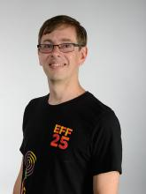

Jeremy Malcolm joined EFF's international team in 2014 and works on the international dimensions of issues such as intellectual property, network neutrality, Internet governance, and trade. Prior to that he worked for Consumers International coordinating its global programme Consumers in the Digital Age. Jeremy graduated with degrees in Law (with Honours) and Commerce in 1995 from Murdoch University, and completed his PhD thesis at the same University in 2008 on the topic of Internet governance. Jeremy's background is as an information technology and intellectual property lawyer and IT consultant. He enjoys acting, writing and coding, and his ambitions include writing an original science fiction novel, learning to juggle and learning Japanese (ideally both at once). Jeremy is admitted to the bars of the Supreme Court of Western Australia (1995), High Court of Australia (1996) and Appellate Division of New York (2009). He is a former co-coordinator of the Civil Society Internet Governance Caucus, founder of Best Bits, and currently a Steering Committee member of the OECD Civil Society Information Society Advisory Council.

Prof. Dr. Maria Beebe from Portland State University (USA) is an applied sociolinguist whose research interests include critical discourse analysis, women’s leadership, and information communication technologies (ICT) for development. She has a Masters of Arts in Anthropology and Ph.D. in Education from Stanford University. Dr. Beebe has over twenty years experience in global development in a wide-range of sectors, including higher education, telecommunications, environment, natural resources, primary health care, and small enterprise development. She has used her expertise as a social scientist and sociolinguist to advance the use of ICT for development. Dr. Beebe has lived and worked in South Africa, Liberia, Philippines, Sudan, and Afghanistan.

Marcela Paiva Veliz is a lawyer and counselor at the Permanent Mission of Chile to the WTO, WIPO, UNCTAD and ITC since 2014. She started her career in the Chilean government in 2007 as advisor to the Minister of Culture, role in which she covered WIPO and APEC meetings among other issues. Later she worked at the General Directorate of International Economic Affairs, first as a legal adviser at the Intellectual Property Department, both in bilateral and multilateral negotiations. Afterwards, she was an adviser to the Director General of International Economic Relations.

Mohammad N Azizi is Chairman at Afghanistan Telecommunication Regulatory Authority (ATRA). Over 2 decades of professional experience as international development expert and technology economist working in national and international organizations, managing projects in diverse sectors (economic development, and finance reform, education, mining, transport and telecommunication development, etc.).

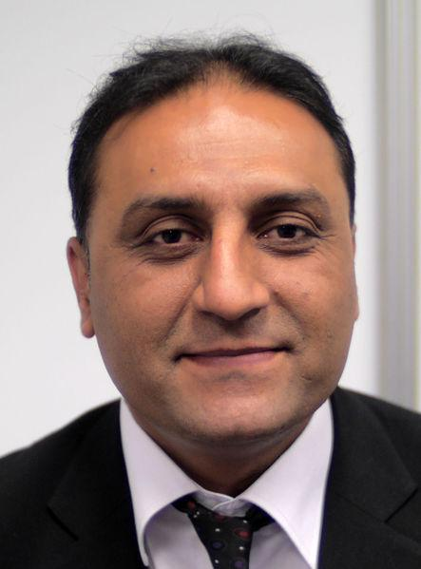

Omar Mansoor Ansari is Afghanistan’s senior entrepreneur and researcher in ICT. He has over fifteen years of experience in building institutions, networks and technology startups. Omar worked with Microsoft Corporation and International Development Research Center (IDRC) on software localization and received Microsoft Localization Champion Award. He has actively been involved in local and global ICT and IG arenas. He involvement includes serving as Co-founder/ Executive Director of Afghan Computer Science Association (ACSA), Founder/ Editor-in-Chief of the Computer Science bimonthly, Chairman of the National ICT Alliance of Afghanistan (NICTAA), Director of Founder Institute Kabul, Board Member of the World IT and Services Alliance (WITSA). Omar has been actively participating in World Summit on Information Society (WSIS) and the IGF processes. He is currently a member of IGF’s Multistakeholder Advisory Group (MAG), founder of TechAfghanistan, a technology information and resource portal, and Vice Chairman of Internet Society Afghanistan. Omar works as full time President of TechNation, a Kabul-based technology and consulting company, .

Renata Aquino Ribeiro is an independent researcher and teacher at E.I. Collective. At Internet Freedom Festival 2017, a fellow in the Regions and Groups track. In ICANN57, a coach. Also part of the MAG IGF – Multistakeholder Advisory Group in the Internet Governance Forum, representing Civil Society. In 2015, she was a professor in the IT Campus at Quixadá City in Federal University of Ceará (UFC), Brazil. In 2014, Dr. Ribeiro was a researcher in social development, technology and education at Business and Economics Faculty (FEAAC) at UFC. For the last decade, followed the internet governance debates such as regional IGFs and ICANN53 participation as fellow, Brazilian Internet School of Governance 2014 fellow, South School of Internet Governance 2015 fellow and LACRALO ALS Nexti participant and NCUC participant in ICANN. She has a PhD completed in 2012 in Education: Curriculum as a part of the research group in Technologies in Education at Catholic University of São Paulo (PUC-SP). Ribeiro is also a Master of Arts in Hypermedia from University of Westminster (UK – 2003), validated in Brazil through University of São Paulo (USP). Her bachelor degree is in Journalism from PUC-SP (1998). Blog: https://pesquisaeducacao.wordpress.com

Susan Aaronson

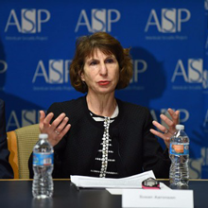
Susan Ariel Aaronson is Research Professor at The George Washington University's Elliott School of International Affairs, GWU Cross Disciplinary Fellow, Cavalho Fellow at the Government Accountability Project, and the former Minerva Chair at the National War College.
Aaronson’s research examines the relationship between economic growth and human rights. She is currently directing projects on digital trade and digital rights, trade agreements and human rights; repression and civil conflict; and whistleblowers in international organizations. She is developing projects on trade liberalization and public health. Working with colleague Esther Brimmer, Aaronson also developed coursework and a curriculum on international Internet issues for the MA program. Her work has been funded by major international foundations including MacArthur, Ford, Rockefeller, governments such as the Dutch, Swiss, US, and Canadian governments, the UN, ILO, and World Bank, and US corporations including Ford Motor and Levi-Strauss. Dr. Aaronson is the author of six books and numerous articles on trade, human rights, digital trade, public private partnerships; globalization, corporate social responsibility; and public understanding of economic change. She is also a frequent speaker on globalization issues. She was a regular commentator on "All Things Considered" in 1994-1995, "Marketplace" from 1995-1998, and "Morning Edition" from 1998-2001. She has also appeared on CNN, the BBC, and PBS to discuss trade and globalization issues. She has also been a Guest Scholar in Economics at the Brookings Institution (1995-1999).
Dr. Aaronson serves on the Advisory Board for Business-Human Rights; the first German-Israeli joint interdisciplinary doctoral program, “Human Rights under Pressure: Ethics, Law, and Politics” (Freie Universität Berlin with the Hebrew University of Jerusalem; the Research Advisory Commission for the Global Commission on Internet Governance, and is a member of Working Group 2 of the Freedom Online Coalition (24 governments working on digital rights). In recent years, she has been a pro-bono advisor to the UN Special Representative on Transnational Corporations and Human Rights, and the Congressional Human Rights Caucus. She has also consulted for the ILO; the World Bank; Free the Slaves; the Extractive Industries Transparency Initiative; the Stanley Foundation; several corporations; and the governments of Canada, Belgium, and the Netherlands, among others. Aaronson is also the Director of the eBay Policy Scholars, a masters fellowship on internet issues
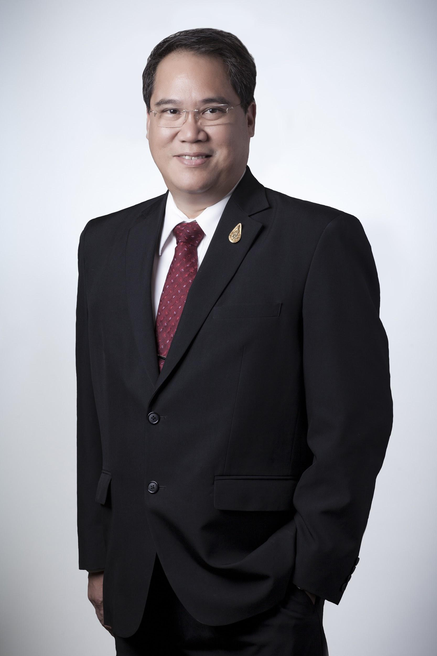

Wanawit Ahkuputra is the Deputy Executive Director of the Electronic Transactions Development Agency of Thailand (ETDA) under supervision of Ministry of Digital Economy and Society. Since the participation in ICANN from 2012 as the role of GAC Thailand ,He appointed as Vice Chair of GAC - Government Advisor Committee at ICANN(Since 2015), IGF MAG - Multi Stakeholder Advisory 2016 and UN Global Pulse - PAG Privacy Advisory Group(2016).
In 2015 the ASEAN caucus appointed Mr. Wanawit to be the Chair of the WGEC - Workgroup on Electronic Commerce of RCEP - Regional Comprehensive Economic Partnership. Mr. Wanawit also work toward the impact of the WTO TFA - Trade facilitation agreement to the E-commerce and Internet community and provide recommendation to stakeholders.
The Royal Thai Government entrusted to him the roles of Head of Delegate of UN/CEFACT and Chairman of AFACT BCD - Asia Pacific Council for Trade Facilitation and Electronic Business Domain Commitee.

