DYNAMIC COALITIONS 2024 WORK PLAN AND TIMELINE
DC Work Plan and Strategic Objectives
IGF-related activities:
- Strategic objective: Share expertise and create synergies amongst the broader IGF intersessional work community.

Suggested action items:
- DC liaisons to NRI meetings, and Best Practice Forums (BPF) and Policy Network (PN) meetings, reporting back to DCCG meetings.
- Active contribution of DC experts to the work of BPFs and PNs.
- Active reach out of DC coordinators and/or members to other DCs dealing with similar IG-related issues to exchange experts and expertise, and best practices.
- Active participation in and contribution to IGF capacity development initiatives (e.g., providing experts in youth and Parliamentary Track workshops).

Key milestones:
- Ongoing

- Strategic objective: Contribute furthermore to the development of and substantive input to the IGF 2024 programme.

Suggested action items:
- Potential organization of a 2024 intersessional event.
- Active participation of DC members in MAG working groups.
- Active participation of DC members in MAG groups organizing main sessions.

Key milestones:
- Ongoing subscription to and participation in MAG working groups on:
  - IGF Strategy (WG-Strategy)
  - Workshop Process (WG-WSP)
  - Multilingualism (WG-Multilingual)
- Subscription to MAG groups organizing main sessions once launched.

- Strategic objective: Develop a proposal for DC’s integration in the IGF 2024 programme.

Suggested action items:
- Potential organization of a virtual IGF 2024 Dynamic Coalition Event Day, ahead of the annual IGF with inputs feeding into the development of a DC main session.
- Potential organization of a DC main session at the IGF 2024.
- Suggestion to organize a joint DC event at the IGF 2024.
- Suggestion to allocate few individual DC sessions on a competitive basis.
- Suggestion to hold DC lightning talks.
- Suggestion to organize a joint DC village booth.
- Suggestion to reserve a bilateral meeting room for individual DC annual meetings.

Key milestones:
- Develop and agree on a proposal latest by 23 February and submit it to the MAG for its review and consideration during the 1st OC and MAG meeting.

- Strategic objective: Advocate for DCs and increase DCs’ visibility and reputation.

Suggested action items:
- Expand DCs network of professionals and members by advocating for DCs at the regional and annual IGFs, and other IG-related events.
- Increase DC’s visibility on the IGF website by promoting DC output documents under Reports and Publications
- Encourage DCs to develop own DC communications strategies in-line with IGF principles (by amplifying IGF (social media) posts, sharing/drafting press releases for the IGF website, integrating key IGF-related milestones into communications timeline…)
- Adhere to the IGF branding manual and templates (in development).

Key milestones:
- Align with IGF communications activities (please see IGF 2024 timeline)

- Strategic objective: Develop a set of KPIs to report back to the MAG.

Suggested action items:
- Further refine the DC governance and update the DC Charter as necessary
- Based on the agreed DC 2024 workplan, develop and agree on a set of KPIs relevant to the various DCs.
- The IGF Secretariat could be tasked to conduct surveys at the end of each year.

Key milestones:
- Refine the 2024 DC governance (beginning 2024, deadline TBD)
- Set of KPIs to be developed and agreed upon (deadline TBD) at the beginning of the IGF 2024 cycle.
- Surveys amongst DCs to be conducted at the end of each IGF cycle (TBC).
- Report of the previous year to be issued prior to the 1st OC and MAG meeting of the following year.

Internet Governance-related processes:
  - Global Digital Compact
- Strategic objective: Participate in and follow the development of Global Digital Compact (GDC) consultations leading to the Pact of the Future agreed at the Summit of the Future in New York on 22 and 23 September 2024.

Suggested action items:
- Active participation in the GDC rounds of informal consultations facilitated by the Office of the UN Envoy on Technology.
- Suggestion to provide written input to the GDC Zero draft.

Key milestones:
- GDC 2024 timeline:
  - 12 February: 1st round of informal consultations with Member States & observers (open for other observers)
  - 13 February: 1st round of informal consultations with relevant stakeholders
  - 29 February: 2nd round of informal consultations with Member States & observers (open for other observers)
  - 1 March: 2nd round of informal consultations with relevant stakeholders
  - 8 March: deadline for written input submission from MS, observers & stakeholders to inform the preparation of the zero draft of the GDC
  - Intergovernmental negotiations:
    - 5 April: first reading of the zero draft
    - 2 May: second reading
    - 16 May: third reading
  - 22-23 September: Summit of the Future and agreement on the Pact

  - NetMundial+10
- Strategic objective: Participate in and follow the development of the NetMundial+10.

Suggested action items:
- Participate in the NetMundial+10 event and submit session proposals.

Key milestones:
- Call for input TBC.
- Participate in NetMundial+10 from 29 April to 1 May 2024.

  - WSIS+20 Review Process
- Strategic objective: Participate in and follow the development of the WSIS+20 review process via open consultations (TBD), call for input, WSIS-related events.

Suggested action items:
- Development of a joint DC response to the CSTD online questionnaire in line with the MAG-LP response.
- Active participation in CSTD open consultations (TBD) and WSIS-related events.

Key milestones:
- Submit the joint DC response by 29 February 2024
- Participate in WSIS+20 Forum High-Level event from 27 to 31 May 2024.

IGF and IG-related Processes
IGF-related Processes (Draft) | Internet Governance related Processes

DC 2024 Timeline

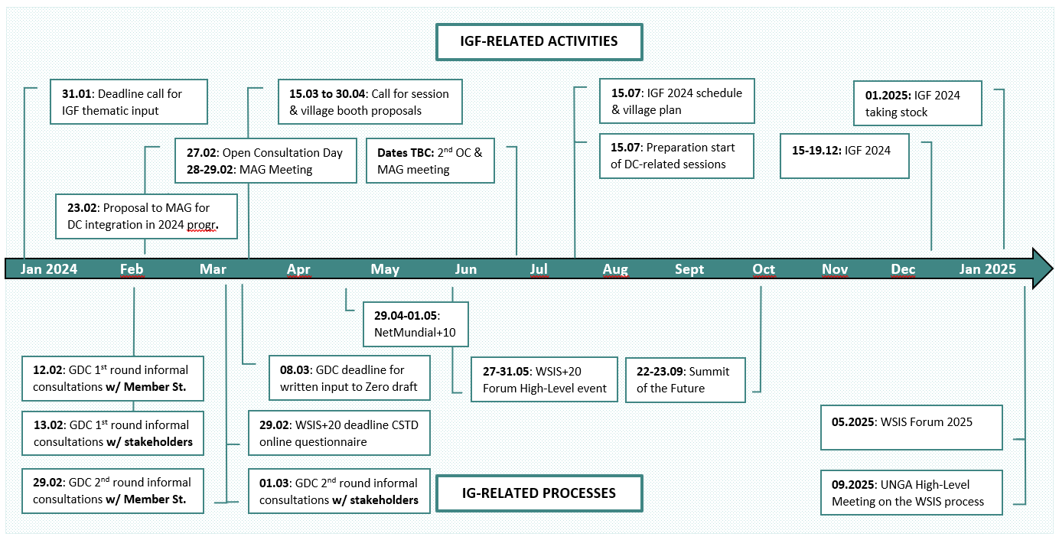

Following the S.T.A.R. approach proposed by the IGF MAG Chair (Strategic, Transformative, Agile, Relevant).
Dates subject to change

